CS300 Assignment
Vector Sorting Project
Joven Rosales
5/18/2026

Code Reflection:

The program was challenging to develop, but its purpose was to provide insight into different types of sorting algorithms that programmers can use. The code structure was to allow users to load bid data from a CSV file, display the bids, and sort the data. By using Selection Sort and Quick Sort algorithms through a menu-driven interface.
In the program, several techniques were implemented, with modular programming being the primary approach. This method established distinct functions for loading, displaying, and sorting bids. Ensuring the code remained clean, organized, and maintainable. Additionally, vectors were employed to store bid information dynamically, as they automatically adjust their size when data is added or removed.
One of the biggest challenges encountered during development was implementing the Quick Sort algorithm correctly. Incorrect recursive boundaries initially caused infinite recursion and stack overflow errors. This issue was resolved by carefully adjusting the recursive calls and ensuring the base conditions properly terminated the recursion. When the beginning index became greater than or equal to the ending index, recursion would terminate.
Additionally, another hurdle was designing a flowchart that clearly represented the menu system and sorting process. This was overcome by organizing the program into a clear decision-based structure that returns to the main menu after each operation.
These development challenges ultimately strengthened my problem-solving abilities and deepened my understanding of algorithm implementation and program design. Working through recursive boundary issues and flowchart organization provided valuable experience in debugging complex code and creating user-friendly interfaces.

Flowchart of Assignment 2 Vector sorting:

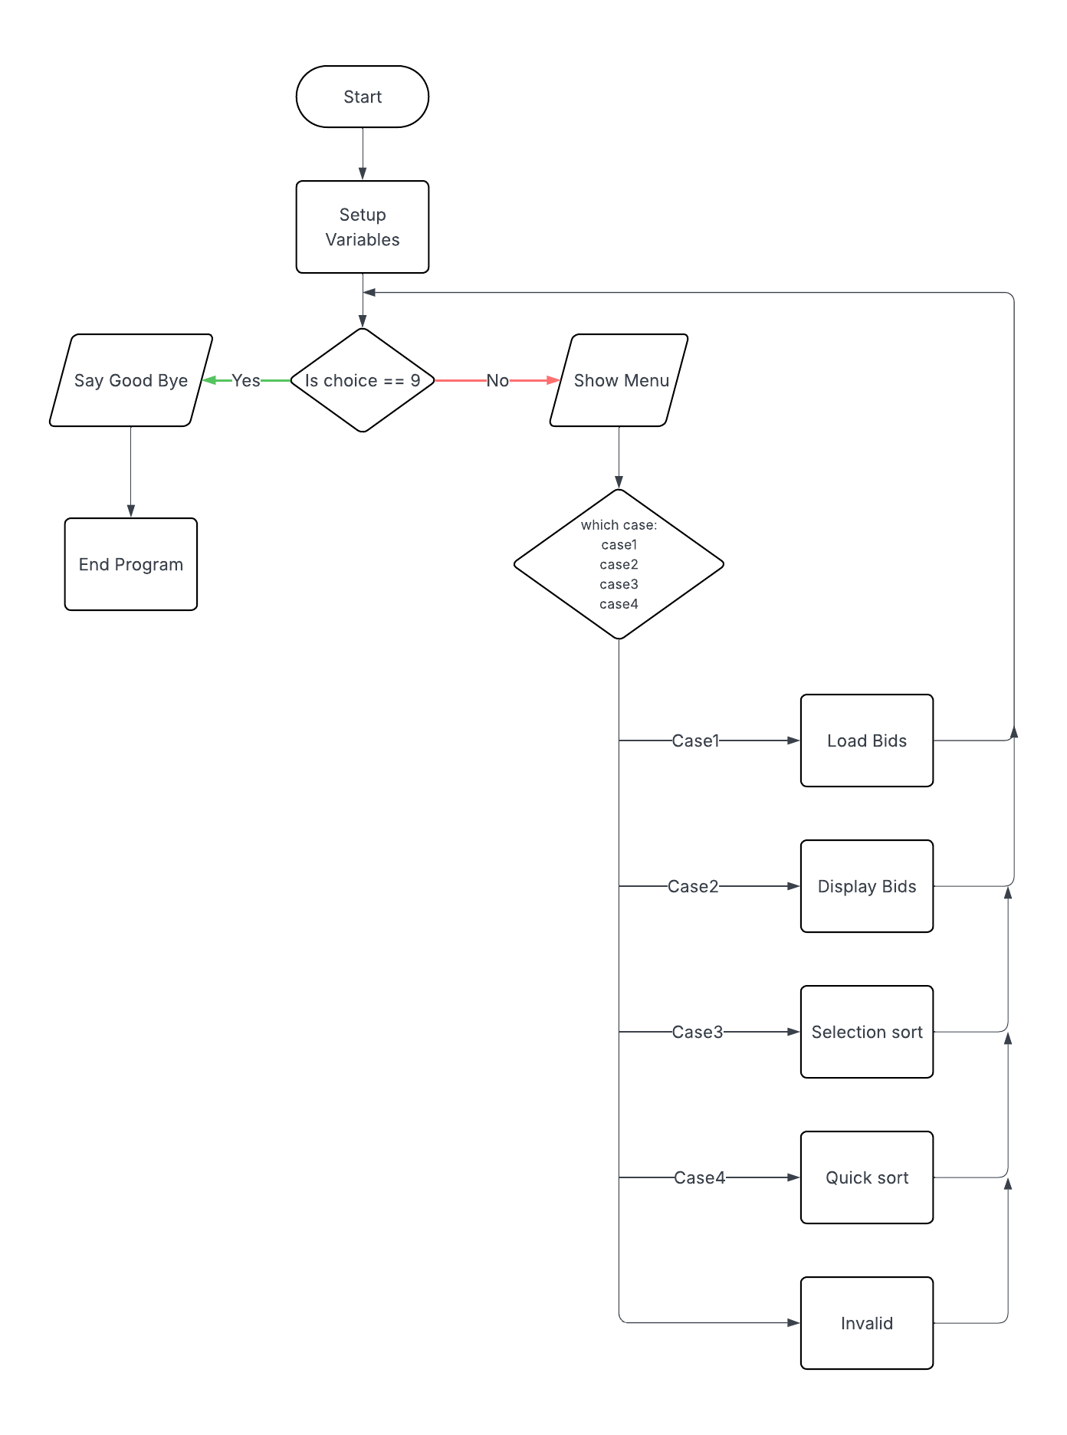

Selection Sort algorithm flow
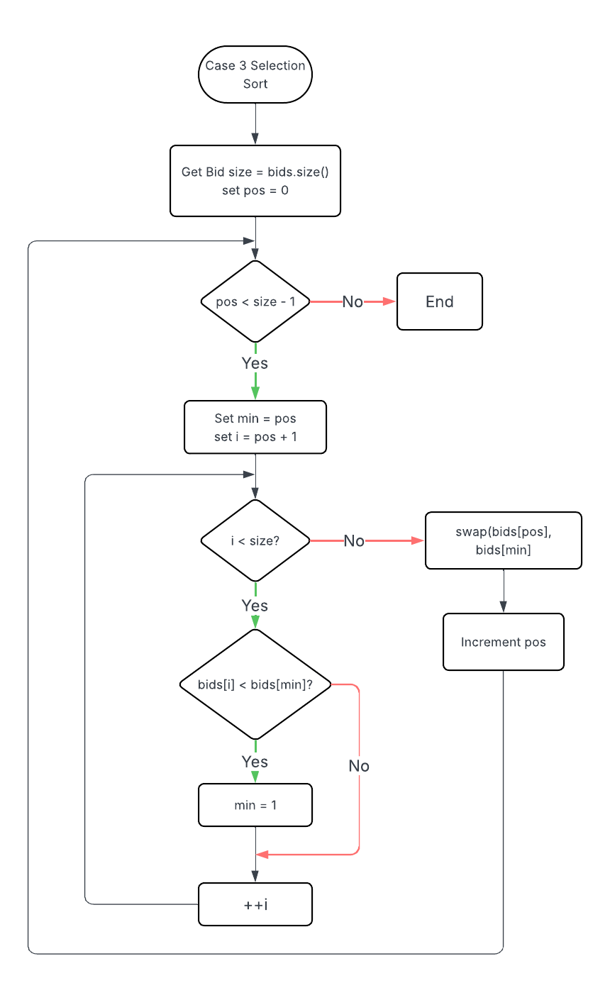

Dynamic Recursive Quick Sort Flowchart:
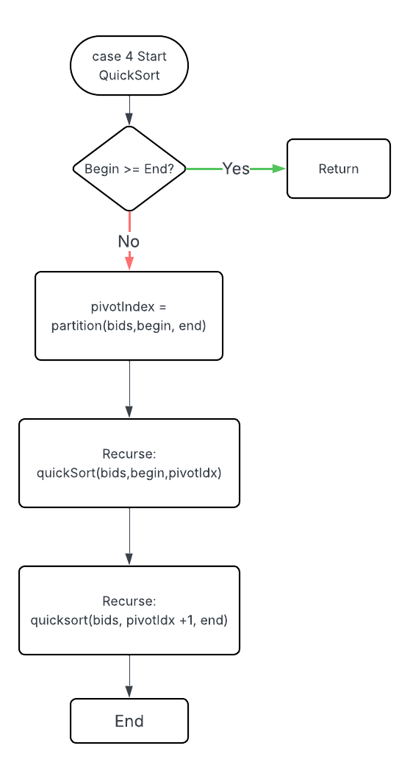

Inner Partition Flowchart:
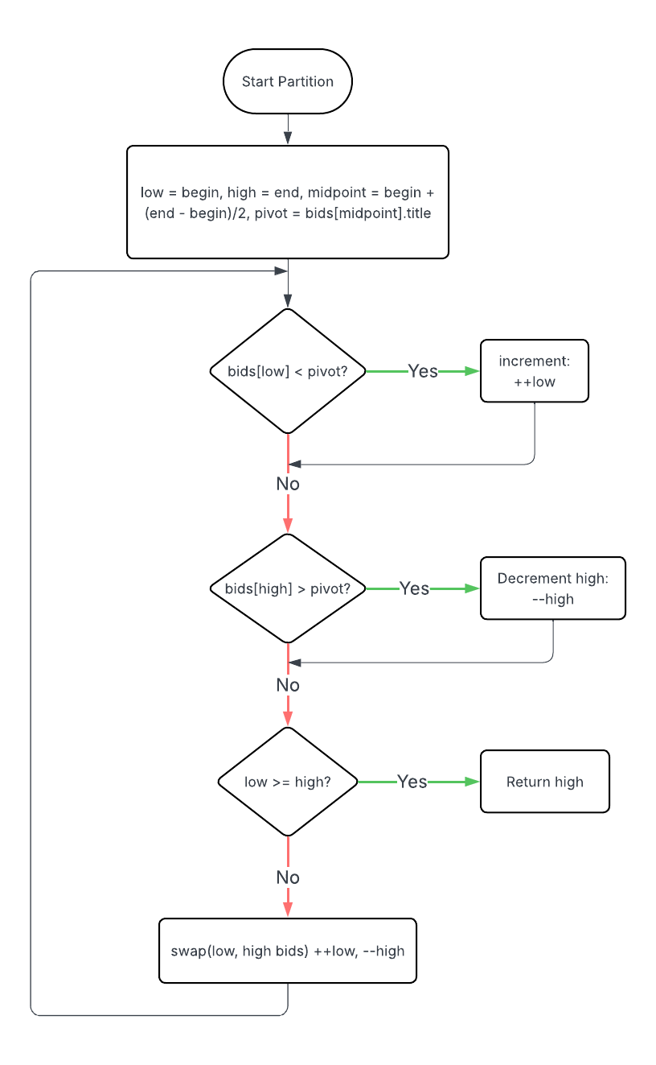

Annotation and Documentation:
Task 1.a.
// FIXME (1a): Implement the selection sort logic over bid.title
void selectionSort(vector<Bid>& bids) {
//define min as int (index of the current minimum bid)
int min;
// check size of bids vector
// set size_t platform-neutral result equal to bid.size()
size_t size = bids.size();
// pos is the position within bids that divides sorted/unsorted
// for size_t pos = 0 and less than size -1
for (size_t pos = 0; pos < size - 1; ++pos) {
// set min = pos
min = pos;
// loop over remaining elements to the right of position
for (size_t i = pos + 1; i < size; ++i) {
// if this element's title is less than minimum title
if (bids[i].title < bids[min].title) {
// this element becomes the minimum
min = i;
}
}
// swap the current minimum with smaller one found
// swap is a built-in vector method
swap(bids[pos], bids[min]);
}
}

Task 1.b.
// FIXME (1b): Invoke the selection sort and report timing results
case 3:
// Start timer
ticks = clock();

// Runs sorting algorithem,
selectionSort(bids);

// Stop timer
ticks = clock() - ticks;

// Display timing results
cout << "time: " << ticks << " clock ticks" << endl;
cout << "time: " << ticks * 1.0 / CLOCKS_PER_SEC << " seconds" << endl;

break;

Task 2.a.
// FIXME (2a): Implement the quick sort logic over bid.title
int partition(vector<Bid>& bids, int begin, int end) {
//set low and high equal to begin and end
int low = begin;
int high = end;
// Calculate the middle element as middlePoint (int)
// Set Pivot as middlePoint element title to compare (string)
int midpoint = begin + (end - begin) / 2;
string pivot = bids[midpoint].title;

// while not done
while (true) {
// keep incrementing low index while bids[low].title < Pivot
while (bids[low].title < pivot) {
low++;
}
// keep decrementing high index while Pivot < bids[high].title
while (bids[high].title > pivot) {
high--;
}
/* If there are zero or one elements remaining,
all bids are partitioned. Return high */
if (low >= high) {
return high;
}
// else swap the low and high bids (built in vector method)
else {
swap(bids[low], bids[high]);

// move low and high closer ++low, --high
++low;
--high;
}
}

return high;

Task 2.b.
// FIXME (2b): Invoke the quick sort and report timing
case 4:
// Start timer
ticks = clock();

// Perform quick sort
quickSort(bids, 0, bids.size() - 1);

// Stop timer
ticks = clock() - ticks;

// Display elapsed time
cout << "time: " << ticks << " clock ticks" << endl;
cout << "time: " << ticks * 1.0 / CLOCKS_PER_SEC << " seconds" << endl;
break;
}
}
Citation:
- zyBooks. (n.d.). Selection sort algorithm pseudocode and implementation examples. CS300 Data Structures and Algorithms course materials.
- Stack Overflow/GitHub help
- Online examples and tutorials
- Starter code provided by the instructor

